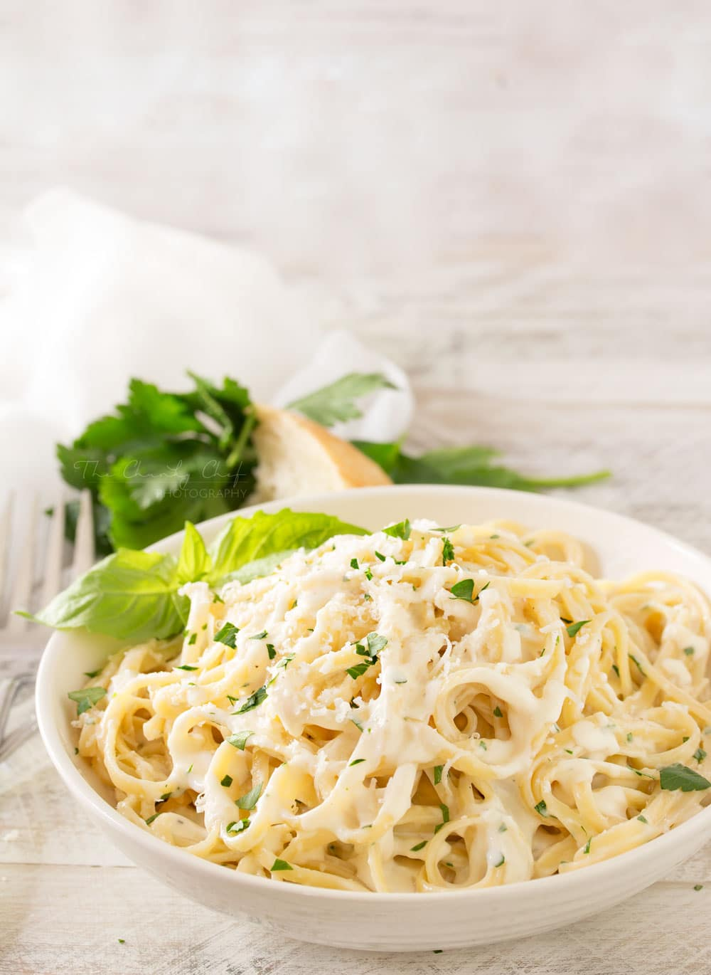
Roasted Garlic Cream Sauce
Prep Time 5 min Cook Time 10 min
4 Servings
Ingredients
1 head roasted garlic
6 Tbsp butter
1 ¾ cup heavy cream
1 ¼ cup Parmesan cheese
½ tsp black pepper
2 tsp flour
1 Tbsp heavy cream
Directions
- Remove cloves of roasted garlic and mash with a fork.
- In a medium saucepan over medium-low heat, add butter and melt.
- Pour in cream and garlic and heat to a simmer.
- Whisk in the black pepper and cheese.
- Combine flour and heavy cream.
- Add flour and cream mixture, and whisk to remove any lumps.
- Continue to whisk until sauce has thickened, a few minutes.

